**VMware Tutorials:**

VMware is the choice for IT professionals creating and managing virtual machines. These VMware tutorials help you understand the cloud-computing and virtualization aspects of the software, and get secondary systems up and running on Windows, Linux, and Mac OS X computers.

***What You Will Learn***

* How to setup your own Hands-on Labs
* Install, configure, and manage the ESXi 6.5 Hosts
* Install, configure, and manage the vCenter Server 6.5 components
* Create and Manage virtual machines, templates, clones, and snapshots
* Create and configure virtual networks and storage devices
* Automate and orchestrate routine administrative tasks
* Create and Manage User Permissions and Privileges
* Configure and manage Security Profile and Firewall

**Who this course is for:**

* System Administrators
* IT Infrastructure Manager
* vSphere Administrators

**What is VMware vSphere ?**

VMware vSphere is not a specific product or software. VMware vSphere is the commercial name for entire VMware suite. The VMware vSphere stack comprises virtualization, management, and interface layers. The two core components of VMware vSphere are ESXi server and vCenter Server. ESXi is the hypervsior, where you create and run virtual machines and virtual appliances. vCenter Server is the service through which you manage multiple ESXi hosts connected in a network and pool host resources.

VMware vSphere is being the master in virtualization industry as compared to other hypervisors such as [Microsoft Hyper-v](http://www.cloudinspiration.com/category/microsoft-hyper-v-2016/) and Citrix Xen Server.

### ****History of VMware vSphere ?****

Prior to VMware vSphere, entire VMware product suite is called “VMware Infrastructure”. VMware renamed its flagship product name “VMware Infrastructure” to “VMware vSphere” with the release of VMware vSphere 4.

VMware first released the VMware Workstation in 1998 which is the root product of VMware. Followed by VMware Workstation, They released ESX (Elastic Sky X) and GSX (Ground Storm X) hypervisors. Where ESX ran directly on the server hardware (bare metal hypervisor) and GSX required a host OS. VMware GSX has be retired but ESX line is now renamed to ESXi with the lot of architectural differences and improvements across each release of ESXi host.

Below are brief product release history of VMware vSphere products shows the evolution of VMware workstation to VMware vSphere 6.5.

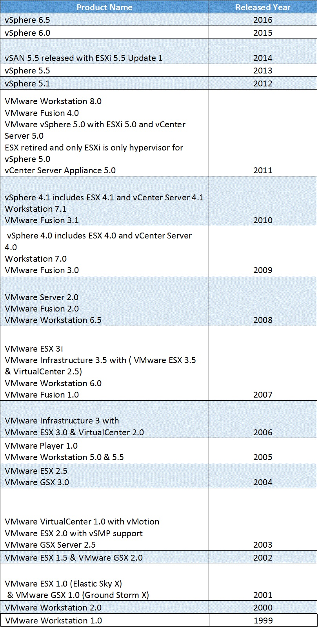

### ****What is VMware ESXi?****

VMware ESXi is the bare metal hypervisor from VMware. VMware ESXi is the piece of software available in the form of ISO which gets installs directly on the physical hardware as same like windows or linux operating systems. ESXi installation is a small footprint with size of 144 MB. Even you can [install ESXi on USB pendrive](http://www.vmwarearena.com/install-esxi-51-using-usb-flash-drive/). VMWare ESXi allows you to create multiple virtual machines in top of it to run multiple operating system such as windows, linux, solaris,macOS,etc in a single physical hardware. It enables you to run your workloads on top of virtual machine which allows you to consolidate multiple physical hardware’s to run your workloads into fewer physical hardware.

Prior to vSphere 5, vSphere has 2 hypervisors ESX & ESXi. With the release of vSphere 5.0, ESXi is the only hypervisor. Take a look at my article to understand [difference between ESX and ESXi](http://www.vmwarearena.com/difference-between-vmware-esx-and-esxi/)

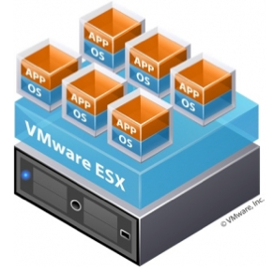

VMware ESXi comes with free and paid version. As you guessed, Free version of ESXi will comes with few limitation as compared to the paid ESXi. You won’t be able to manage your free ESXi hypervisor using vCenter Server. I will explain about vCenter server in a little while. Eventhough Free ESxi have few limitations which is far enough to work with that on lab purposes, POC, evaluation before upgrading to advanced versions of ESXi and even in test & development purposes.

How do you build home lab using VMware ESXi. You can even install VMware ESXi in top of VMware Workstation. Take a look at my article to understand how to install ESXi on VMware Workstation  
[Install ESX/ESXi Server on VMware Workstation – Part 1](http://www.vmwarearena.com/install-esx-server-on-vmware/)  
[Install ESX/ESXi Server on VMware Workstation – Part 2](http://www.vmwarearena.com/install-esxesxi-server-on-vmware/)

Upgrading from free version of ESXi to advanced paid version of ESXi is just an seemless by updating the new license keys.

**Articles related to Free VMware ESXi hypervisor:**  
[vSphere 5.5 – ESXi 5.5 Free version with no more 32 GB RAM hard limit](http://www.vmwarearena.com/vsphere-55-esxi-55-free-version-with-no/)  
[vSphere 5.5 – Download Free ESXi 5.5 License Keys](http://www.vmwarearena.com/vsphere-55-download-free-esxi-55/)  
[vSphere 6.0 – Download Free ESXi 6.0 License Keys](http://www.vmwarearena.com/vsphere-6-0-download-free-esxi-6-0-license-keys/)  
[Download VMware vSphere 6.5 – Get your Copy to Evaluate!!!](http://www.vmwarearena.com/download-vmware-vsphere-6-5-get-copy-evaluate/)

### ****What is VMware vCenter Server?****

VMware vCenter is the software which helps you to centrally manage your entire VMware Virtualzation infrastructure. vCenter can add about thousands of ESXi hosts into the inventory which allows you to manage multiple ESXi hosts and also virtual machines running on the ESXi hosts. vCenter Server provides lot of vSphere features such as VMware DRS, VMware HA (High Availability), VMware vMotion , VMware Fault Tolerance, Virtual machine templates, VM cloning,etc. We will talk about each of the features in detail in the upcoming posts. Take a look at my article to understand the [difference between clone and Template](http://www.vmwarearena.com/vmware-interview-questions-and-answers-2/).

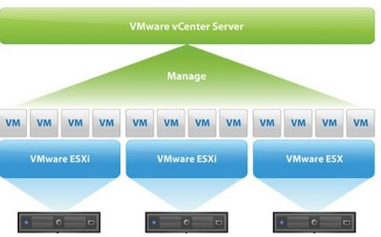

VMware vCenter can be installed on Windows or via linux based vCenter called vCenter Server Appliance. Which was recently switched from SUSE to Photon OS (VMware’s Operating system) on [vSphere 6.5](http://www.vmwarearena.com/category/vsphere-6-5/).  To understand the difference between [Windows based vCenter server and vCenter Server appliance.](http://www.vmwarearena.com/difference-between-vcenter-server/) You need to have an external database  such as Microsoft SQL server,Oracle,etc or embedded database such as PostgreSQL to install vCenter Server. PostgreSQL become embedded database from vSphere 6.0 prior to that Microsoft SQL server Express edition was the embedded database for VMware vCenter Server. vCenter server databases  stores the information about virtual infrastructure inventory objects such as ESXi host information, Virtual machine information along with the performance data.

### ****What is vSphere Client and vSphere Web Client?****

I hope your got basic idea about what is VMware vSphere, VMware ESXi and VMware vCenter Server. Let’s foucs on what is vSphere Client and vSphere Web client. vSphere client and vSphere web client is nothing but the Client software which helps the end-user to connect to the vCenter Server. In simple terms, It is same as the RDP client  which helps you to remotely connect your windows server. Similar to that , vCenter server is a software running on Windows or even Photo OS based appliance will just run as service. We need vSphere Client or vSphere Web client to connect to the vCenter server and manage the virtual infrastructure.

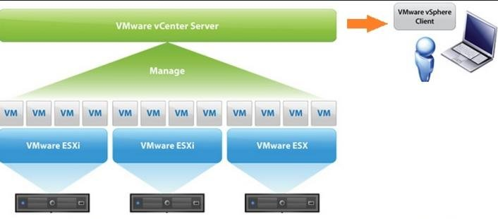

vSphere Client is the client software which needs to be installed on the user desktop or laptop but vSphere Web client is the browser based client. You don’t need to install client software to manage vCenter server using vSphere web client. You can even manage ESXi host directly using vSphere Client but vSphere Web Client can only use to manage vCenter Server. We can also manage ESXi 6.5 host using host client via Web browser.  There will be no more vSphere Client (windows based) from vSphere 6.5. We need to use only vSphere Web Client to manage the VMware virtual infrastructure from vSphere 6.5 onwards.  
[Download link for All Versions of VMware vSphere Client](http://www.vmwarearena.com/download-link-for-all-versions-of-vmware-vsphere-client/)  
[vSphere 6.0 What’s New – Improved and Faster vSphere Web Client](http://www.vmwarearena.com/vsphere-6-0-whats-new-improved-and-faster-vsphere-web-client/)